**EXPN-3 PROPERTY BUYING**

**AIM:**

To Create a simple cloud software application for Property Buying & Rental process (In Chennai city) using any Cloud Service Provider to demonstrate SaaS.

**PROCEDURE:**

**step1: Go to zoho.com.**

**step 2: Log into the zoho.com.**

**step 3: Select one application step.**

**step4: Enter application name as property buying & rental.**

**step 5: Created new application as property buying & rental.**

**Step 6: Select one form**

**step 7: The software has been created.**

**IMPLEMENTATION:**

**STEP1: GOTO ZOHO.COM**

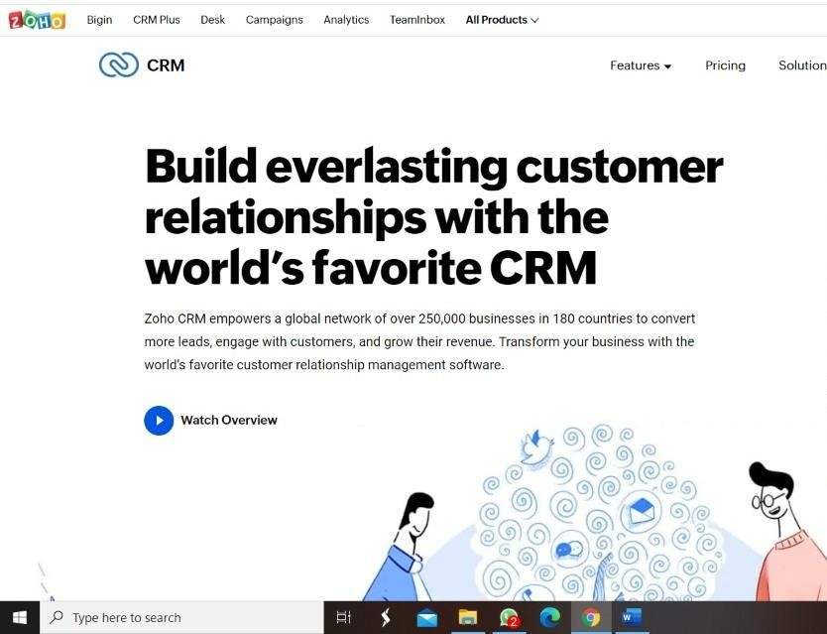

**STEP 2: LOGINTOTHE ZOHO.COM**

**STEP 3: SELECT ONE APPLICATION**

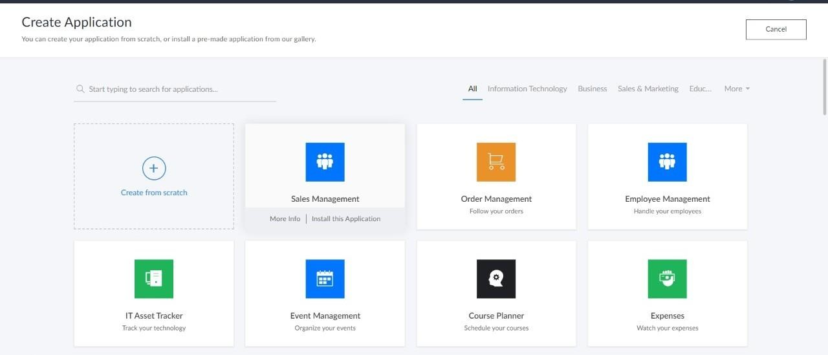

**STEP 4: ENTER APPLICATION NAME**

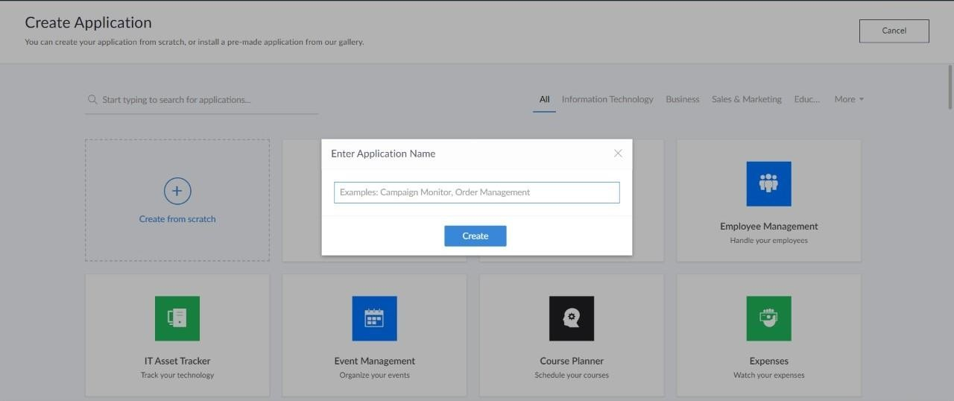

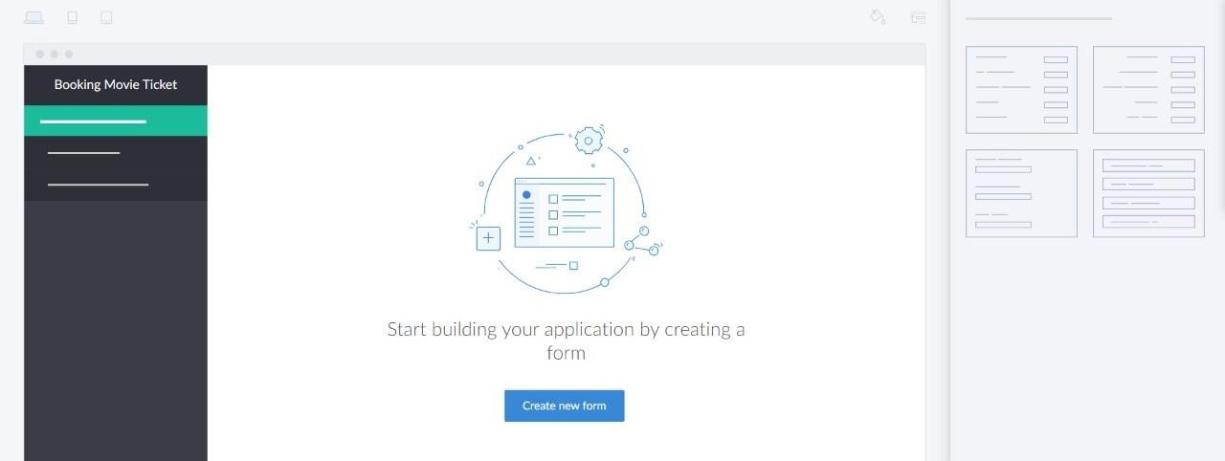**STEP 5: CREATED NEW APPLICATION**

**STEP 6: SELECT ONE FORM**

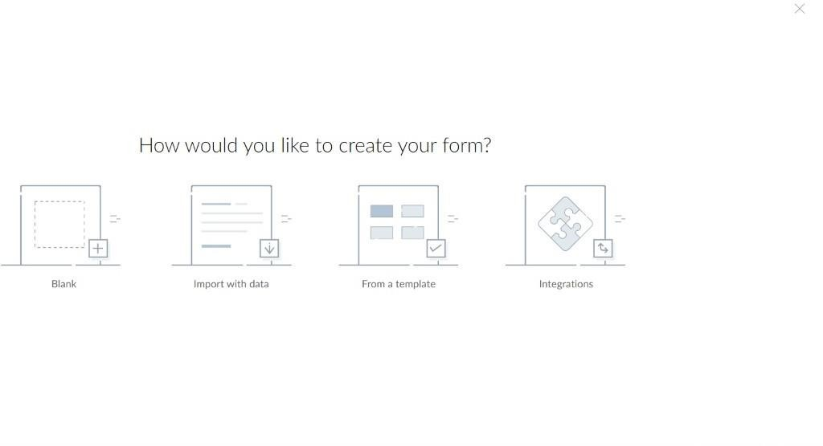

**step 7: The software has been created.**

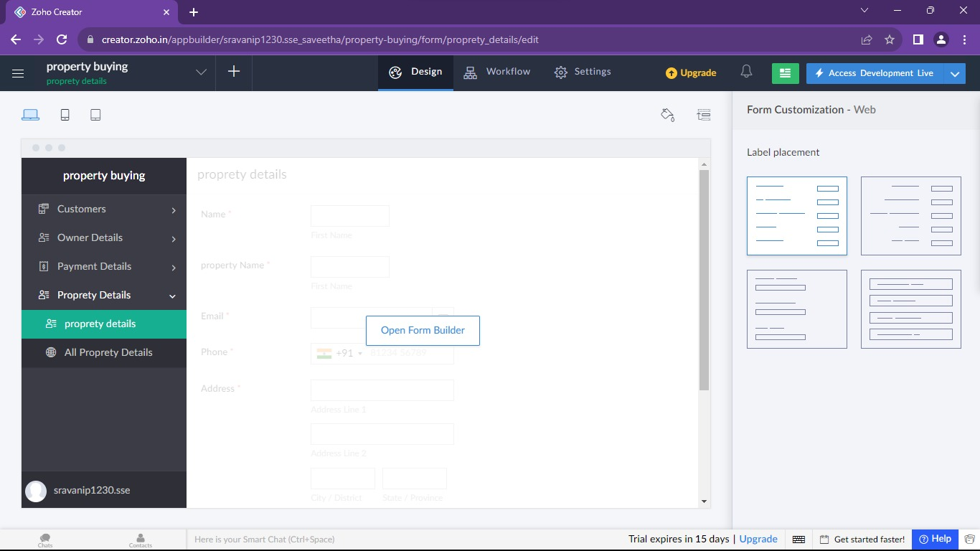

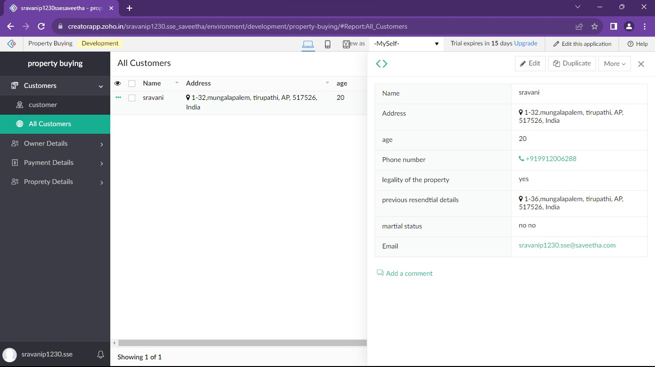

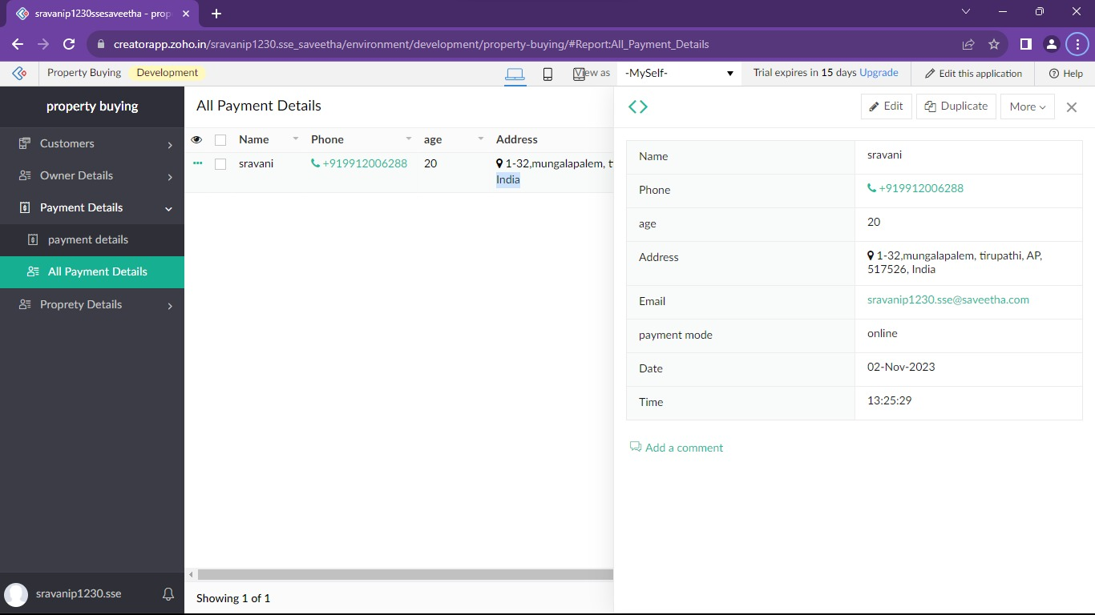

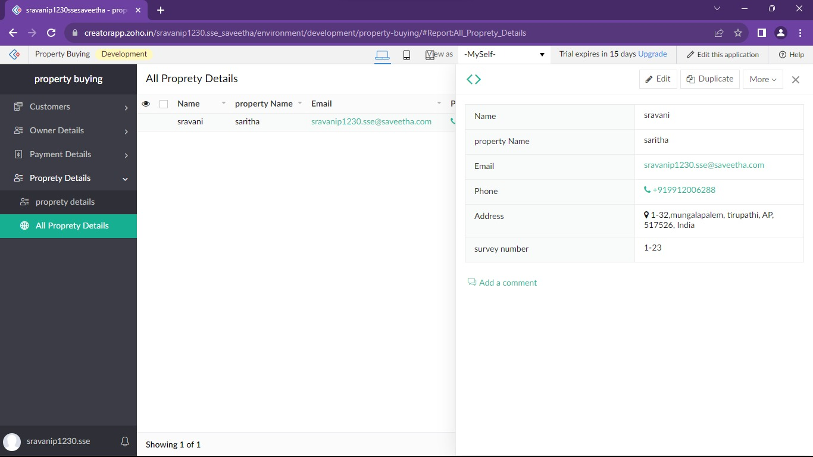

**Result:**

Successfully Developing a property buying system with Zoho ensures scalable, secure, and integrated solutions for seamless user experiences**.**